**CyCIF antigen retrieval**

**Materials**

1. Histoclear
2. Retrieval Buffer* (see bottom for mixing info and choices)
3. Ethanol
4. PBS
5. Tap water
6. Intercept Blocking Buffer with 0.05% Triton X-100 (odyssey is now branded as intercept) (referred to as **blocking buffer**)

**Protocol Rehydration**

1. De-paraffinization: Heat slides for 15 min @60°C. Incubate in Histoclear 10 min x2 and once for 30 min. Use fresh Histoclear every time you start a MxIF project
2. Rehydration: Incubate in EtOH 100% x3, 95% x2, 75%, then in tap water for 5 min each.

Next, antigen retrieve with one of the following buffers (citrate pH 6 or Tris-EDTA pH 9). Follow the appropriate section for chosen retrieval buffer

**Protocol Citrate pH 6.0**

1. Antigen retrieval: Pour citrate buffer in a Coplin jar (plastic) to completely cover tissue on slide. Pour water into to pressure cooker to make a pool around 25mm deep (no need to be exact). Place the jar containing slides (do not tighten lid) in the cooker. Put the cooker lid on and lock it, check the pressure knob at the position “Pressure.” Set Menu–High, Time–15 min and Start.
2. After cooking (15 min) and pressure gets down (additional 20 min), release the pressure knob and open the lid.
3. Place the Coplin jar in an ice-water bucket until the buffer becomes cool and clear.
4. Wash slides in PBS (Keep slides in PBS in a Coplin jar at 4°C, if need to wait for scanning)
5. Pre-blocking for 1 hr @RT with blocking buffer.

**Protocol Tris-EDA pH 9.0**

1. Antigen retrieval: Pour Tris-EDTA buffer in a Coplin jar (plastic) to completely cover tissue on slide. Pour water into to pressure cooker to make a pool around 25mm deep (no need to be exact). Place the jar containing slides (do not tighten lid) in the cooker. Put the cooker lid on and lock it, check the pressure knob at the position “Pressure.” Set Menu–High, Time–3 min and Start.
2. After cooking (3 min), immediately release the pressure knob and open the lid once pressure is fully released.
3. Add in large amounts of cool water into pressure cooker to rapidly cool down.
4. Place the Coplin jar in an ice-water bucket until the buffer becomes cool and clear.
5. Wash slides in PBS (Keep slides in PBS in a Coplin jar at 4°C, if need to wait for scanning)
6. Pre-blocking for 1 hr @RT with blocking buffer.

Making Tris-EDTA pH 9

1. 800mL distilled water
2. Add 1.21g Tris-CL
3. Add 0.37g EDTA
4. Add distilled water until vol 1L reached
5. Adjust pH with 1M HCl until pH 9 (started at about pH 10 for me)
6. Add 0.5mL tween-20

Making Citrate Buffer

1. 2.94g of trisodium citrate dihydrate
2. Add 950mL distilled water
3. Adjust pH to 6.0 via NaOH (usually 10M or 1M)
4. Add 0.5mL tween-20
5. Top off to 1000mL

**Source Material**

Tris-EDTA is from AbCAM

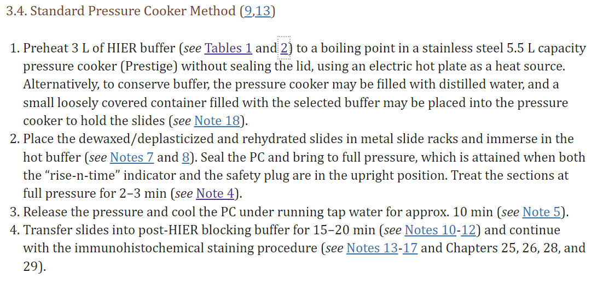

Citrate is from Vanderbilt group and below:

**1.** De-paraffinization: Heat slides for 15 min @60°C. Incubate in Histoclear 10 min x2 and once for 30 min.

Use fresh Histoclear every time you start a MxIF project

**2.** Rehydration: Incubate in EtOH 100% x3, 95% x2, 75%, then in the water for 5 min each.

**3.** Antigen retrieval: Make citrate buffer in a Coplin jar (50 mL, up to 8 slides). Add water to a pressure cooker. Place the jar containing slides (not tighten lid) in the cooker. Put the cooker lid on and lock it, check the pressure knob at the position “Pressure.” Set Menu–High, Time–15 min and Start. After cooking (15 min) and pressure gets down (additional 20 min), release the pressure knob and open the lid. Place the Coplin jar in an ice-water bucket until the buffer becomes cool and clear.

**4.** Wash slides in PBS (Keep slides in PBS in a Coplin jar at 4°C, if need to wait for scanning)